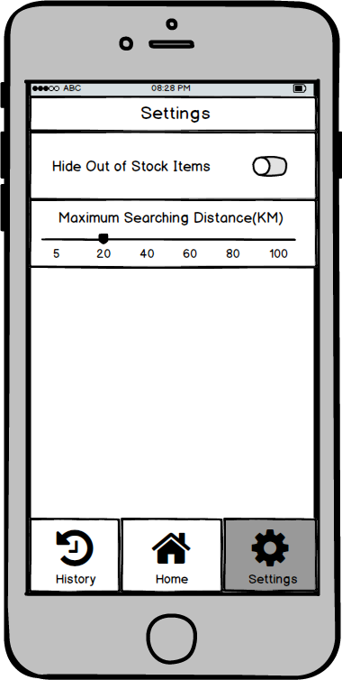

**O 828 PM Settings**

**Hide Out of Stock Items**

**Maximum Searching Distance(KM)**

5 2O 40 60 8O 1OO